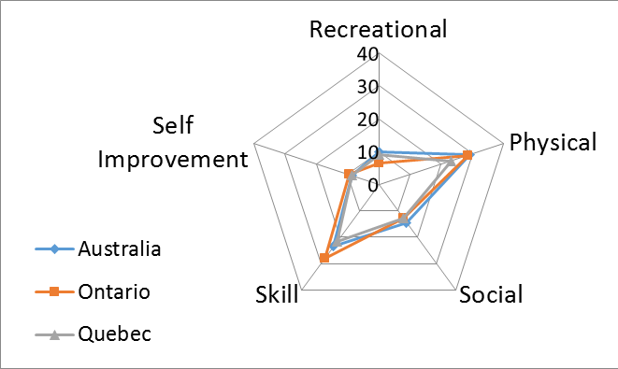
Supplementary Figure 1. Regional differences in proportions Not Doing Preferred activities by Activity Type. The polar graph axes display each of the five Activity Types. Each bar of the graph equates to an increase in proportion of 10%. The three regions are plotted in different colours. The further from the center of the graph, the greater the percentage of children Not Doing Preferred activities in each region.

