Participant code _____________________________

This is a posterior-anterior chest radiograph. Please mark 1-4 where you think the likely location for a single pulmonary nodule would occur, with 1 = most likely, 2 = likely, 3 = less likely, 4 = least likely.

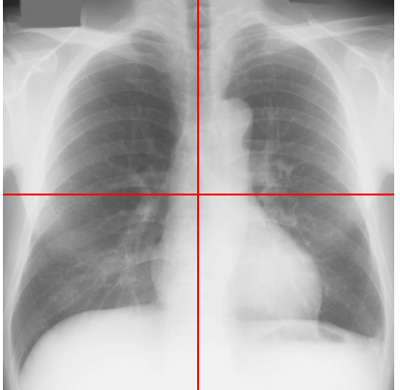

**L**

Do you know the frequencies of nodules in different areas? Yes/No

Thank you for your time ☺