**Supplementary information**

**Figure 1**

Conditional Scatterplots for all Continuous Variables Included in Model 2

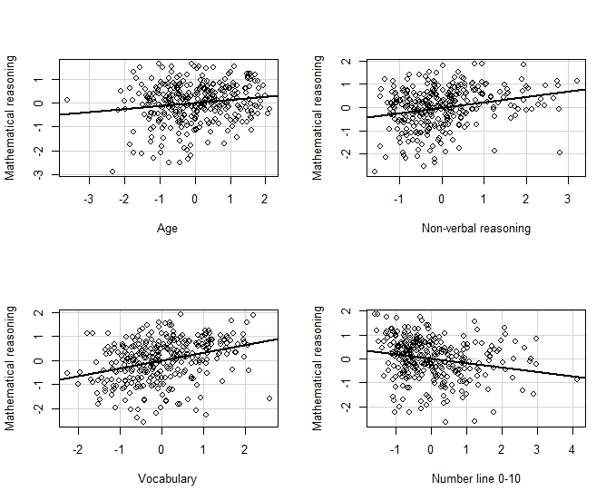

*Note.* Each plot reflects the relationship between the named predictor and mathematical reasoning after accounting for all other predictors included in Model 2.

**Figure 2**

Conditional Scatterplots for all Continuous Variables Included in Model 3

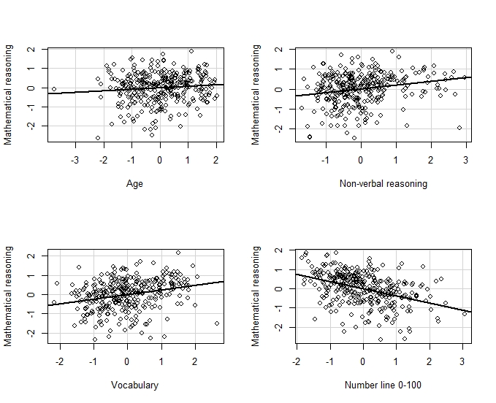

*Note.* Each plot reflects the relationship between the named predictor and mathematical reasoning after accounting for all other predictors included in Model 3.

**Table 1**

*Quantile Regression Results with Only Number Line as Predictor*

|  |  |  |  |  |  |  |  |  |  |  |
| --- | --- | --- | --- | --- | --- | --- | --- | --- | --- | --- |
|  | 10th percentile | | 25th percentile | | 50th percentile | | 75th percentile | | 90th percentile | |
|  | Estimate | *SE* | Estimate | *SE* | Estimate | *SE* | Estimate | *SE* | Estimate | *SE* |
| **For 0-10 number range** |  |  |  |  |  |  |  |  |  |  |
| Intercept | -1.420*** | .161 | -.640*** | .083 | .107 | .072 | .730*** | .064 | 1.153*** | .070 |
| Number Line 0-10 | -.246* | .109 | -.477*** | .087 | -.314*** | .082 | -.283*** | .074 | -.200* | .081 |
| AIC | 1137.70 | | 1007.35 | | 925.84 | | 907.10 | | 931.21 | |
|  |  |  |  |  |  |  |  |  |  |  |
| **For 0-100 number range** |  |  |  |  |  |  |  |  |  |  |
| Intercept | -1.229*** | .119 | -.572*** | .075 | .123 | .069 | .633*** | .056 | 1.020*** | .043 |
| Number line 0-100 | -.665*** | .112 | -.570*** | .072 | -.572*** | .070 | -.482*** | .059 | -.405*** | .045 |
| AIC | 1055.16 | | 940.17 | | 858.28 | | 828.77 | | 848.77 | |
| *Note*. Number line was entered as z scores and smaller values represent better performance.  \**p* < .05. \*\**p* < .01. \*\*\**p* < .001. | | | | | | | | | | |