The Three Rs and Beyond: Public Perceptions on the Role of Australian Local Government Today

Introduction
Although Australian local governments have traditionally been limited by their state and territory governments to administering a relatively select number of services to property – which accounts for their association with the ‘Three Rs’ (roads, rates, and rubbish) – their roles have diversified over time and, during the last several decades, have come to incorporate a wider range of social services, regulatory functions, and quality of life initiatives (Grant and Drew, 2017; Ryan and Woods, 2015; Megarrity, 2011; Dollery et al., 2006). Writing almost 20 years ago, Paul Bell (2006: 177), a former president of the Australian Local Government Association, already confirmed that in addition to the Three Rs, local councils could ‘add regulation, recreation, relief (as in welfare, childcare, aged care and health care services), regionalism and regional development, and retail services such as water, sewerage and transport services’ to the list of roles they performed for their local communities. Some councils, he noted, were also getting involved in ‘arts and culture, management of health, alcohol and drug problems, community safety and accessible transport’. This was, in fact, one of the key conclusions of the 2003 Hawker Parliamentary Report: ‘Local governments’ roles, therefore, are diverse’ (Hawker, 2003). Not only that, but there has been a distinct ‘expansion of the roles beyond those traditionally delivered by the local sector’. Today, it is not uncommon to see local councils offer as many as 140 distinct services, ranging from water and sewerage, planning and development, urban regeneration, health and aged care, recreational and sporting facilities, arts and culture, economic development, to local environmental management.
Taken together, these shifts signify a sector that – while still ‘structurally weak’ – has been on a visible ‘growth path’ beyond ‘mere “administrative practice”’ (Brown, 2006: 23; Grant and Drew, 2017: 71). Indeed, even though Australian local governments continue to remain significantly weaker than their OECD counterparts – for instance, compared with the United States, where local governments’ share of own-purpose public expenditure sits at approximately 24 percent of total government spending, Australian local governments’ share sits only at around six percent (Brown, 2008) – a range of factors have contributed to the growth of local government roles and responsibilities in Australia over time. Chief among these factors is devolution, ‘raising the bar’, cost-shifting, and increased community expectations (Commonwealth Grants Commission, 2001).
But despite the growing consensus among many local government scholars and practitioners that the sector has now moved beyond the Three Rs (Productivity Commission, 2012), there remains a trenchant perception in public debate that when local councils do more than provide a restricted range of local services to property they are overreaching. As recent news headlines like The Guardian’s ‘Council of war: how much should local government stray from roads, rates and rubbish?’ and the Courier Mail’s ‘Stick to collecting rubbish – not spreading it’ suggest, when local councils engage in activities and initiatives that fall under the ‘services to people’ category, they are often met with public criticism that they are exceeding their remit and neglecting their ‘core purpose…to collect rubbish, fix local roads and keep rates down’ (Rozner, 2020).
But to what extent do these views reflect Australian public opinion? In this practice review article, we present the findings from a new national survey of 1,350 respondents who were asked what they saw the role local government to be, what services they think the sector should deliver, and whether acting on controversial issues, such as those relating to national identity, refugee support, and climate change for example, should be within local government’s remit. Here, the article’s objective is to focus broadly on the practice implications of the survey findings and to analyse them against the scholarly literature rather than to provide answers to narrow research questions. Overall, we found three key things. First and most significantly, Australians now have an expansive and more ideational view of the role of local government. Second, there appears to be growing acceptance among Australians that local government’s remit should include engaging with contentious and divisive issues that were previously the reserve of higher levels of government. Third and finally, the type or categorisation of local council – metropolitan, metropolitan fringe, regional, and rural – does not seem to be a determining factor in how Australians conceive of local government’s role in Australia.
Understanding public perceptions on the role of Australian local government is important not only because it is the least understood and most neglected tier of government in Australia (Grant and Drew, 2017; Aitkin and Jinks, 1982). It also provides local government actors and urban policy analysts and planners a broader evidence base to assess the services that the community values and desires, which in turn enables them to better meet both their service delivery and democratic responsibilities (Aulich, 1999). Moreover, national public opinion data on local government roles and services may be particularly useful for guiding local government policy-making as more local councils engage with controversial social issues well beyond the traditional remit of local government and, in so doing, contribute to the burgeoning literature in this area (Chou and Busbridge, 2020).

Survey Parameters and Design
The national survey we designed sought to measure public opinion on three broad areas relating to Australian local government roles and responsibilities. First, the survey asked respondents to think broadly about the role that local government plays in Australia. Specifically, respondents were asked to indicate the extent to which they agreed or disagreed with eight general statements (Appendix A) designed to measure whether Australians see the role of local government as being limited to providing basic services (related to roads, rates, and rubbish) or whether they see this tier of government as having a more expansive role. Here, we selected a range of roles that encapsulates local government as a democratic institution – rather than just a service delivery one – including, whether local government should reflect and advocate for local community needs and values, be further empowered to shape local identity, engage in national issues, and contribute to making society healthier and fairer. Scholarship is now clear about the expansion of roles from ‘services to property’ to ‘services to people’ in local government (Dollery et al., 2010). There is also increasing evidence to show that local councils are playing a greater place-shaping role, which includes initiatives and activities such as ‘building and shaping local identity’, ‘representing the community’, and ‘maintaining the cohesiveness of the community’ (Dollery et al., 2008: 492). However, there remains a lack of systematic understanding of how the Australian public understands these expanding roles. The only national survey on comparable themes, undertaken by the now defunct Australian Centre of Excellence for Local Government almost a decade ago, found that ‘Australians believe it is important that local governments deliver a diversity of activities, with planning for the future being amongst the most important considerations’ (Ryan et al., 2015: iii). Our survey is intended to speak to – and update – these themes and findings.
Second, the survey asked respondents to assess a selection of specific local government services and activities, and to rate which were more important for local government to engage in (Table 1). Here, the objective was to allow respondents to evaluate the importance of a variety of local government services and activities. Again, the services included covered both traditional services to property (i.e. sewage, land use planning, and waste management) as well as the newer and, in some cases, more controversial services to people (i.e. arts and culture, youth services, refugee support, provision of supervised injecting rooms). It should be said that the services and activities our survey listed are not exhaustive, but only indicative of the broad types of services and activities local governments engage in. Given that local governments now provide in some cases well over 100 distinct services, it is impossible to include all of them in a survey like this. Rather, the objective here was to familiarise respondents with the broad types of activities and allow them to assess their importance. As the roles that Australian local governments play change and expand, it is fundamentally important to for citizens to weigh in on whether the local public goods and services offered reflect their preferences as residents and ratepayers (Watt, 2006). After all, as Colebatch and Degeling (1986) argue, tailoring local service provision for local residents is one of the key justifications for local government.

Table 1. How important is it to you that local government engage in each of these services and activities?

- Water, sewage, stormwater, drainage  - Roads and bridges  - Parks  - Footpaths and cycleways  - Land use planning and development applications  - Street cleaning and waste management  - Health  - Provision of supervised injecting rooms  - Childcare  - Climate change and environment  - Aged care  - Emergency and disaster management | - Libraries  - Sporting and recreation facilities  - Reconciliation and Indigenous issues  - Arts and culture  - Economic development  - LGBTQIA+ support and advocacy  - Youth services  - Community development  - Refugee support  - Planning for the future  - Promoting the benefits of the local area  - Lobbying the state government  - Lobbying the federal government

Third, the survey asked respondents to consider in isolation local government’s involvement in contentious political issues. The objective was to have respondents focus explicitly on the increasingly political and ideational roles that Australian local councils can play (Grant and Drew, 2017). While local governments in countries such as the United States have long engaged with contentious culture war conflicts (Sharp 1996, 1999; Brown et al. 2005; Rosenthal 2005; Palus 2010), local councils in Australia have only recently been emboldened in greater numbers to engage with ideologically divisive issues traditionally reserved for higher levels of government and national political debate (Chou and Busbridge 2020). The issues that local councils are now confronting in this realm are diverse, but three of the most prominent and polarising relate to issues associated with climate change, Indigenous reconciliation, and LGBTQIA+ advocacy (Greenwich and Robinson 2018; Greenfield et al., 2022; Busbridge, 2023). Given this, our survey focused on these three broad issues, but also enabled respondents to separate the various issues and actions connected with each of these broad areas that local councils have acted on (Table 2).

Table 2. To what extent do you think local government should be engaging in these issues, in particular in relation to:

- Climate change  - Declaring climate emergencies  - Achieving net zero emissions and 100% renewable energy  - Lobbying federal and state governments for climate action  - Australia Day  - Changing the date of Australia Day from January 26 | - Recognising Indigenous perspectives  - Advancing reconciliation  - LGBTQIA+ advocacy  - Flying the rainbow flag  - Supporting LGBTQIA+ communities  - Fostering LGBTQIA+ inclusive cultures

While the survey’s main objective was to determine how Australians, in general, view local government, it also sought to examine whether there were differences in opinion when views were broken down by two key demographic variables (age and gender) and one central place-based variable (council type). Because different services and issues can be more or less salient for different groups in different places, examining these variables provides local government representatives, administrators, and urban planners an important perspective on how different services might be targeted more effectively across the community. While it is important to concede, too, that local governments can be quite distinct from one state to another, we do not conduct a state and territory analysis here given the national focus of our survey.
The survey was fielded as an online survey through the reputable survey company, Lucid (which has now become part of Cint). Lucid provides access to respondent panels in Australia with hundreds of thousands of adults over the age of 18 who have volunteered to partake in surveys across the country. A random sample of individuals in these respondent panels were recruited and invited to take part in our survey, making this the typical convenience sample that can be gathered from online surveys of this kind. To ensure that the survey accurately reflected the national population, the survey included precise quotas for gender, age, and state/territory of residence, which were based on up-to-date population weights drawn from Australian Bureau of Statistics data. Employing these population weights helped mitigate inevitable sampling biases. These demographic questions were posed first to respondents. Only those who fell into categories where the quotas were not yet filled were able to move onto the survey itself. The resulting sample was 1,350 respondents. The survey was fielded online from 24 June to 3 July, 2022.

Results
The role of local government
Across our sample, 70 percent of respondents agreed that local governments should focus on providing only basic services (Figure 1). While this indicates broad support for the view that local governments should stick to the Three Rs, it is noteworthy that considerably more respondents believed that local governments should do more, with 93 percent agreeing that local governments should advocate for the needs of the local community and reflect community values, 91 percent believing that local government should contribute to a healthier and fairer society, 86 percent suggesting that local governments should be actively shaping local identity and culture, and 83 percent indicating that local government should be a place where national issues can be debated locally.

Figure 1. Views on the role of local governments
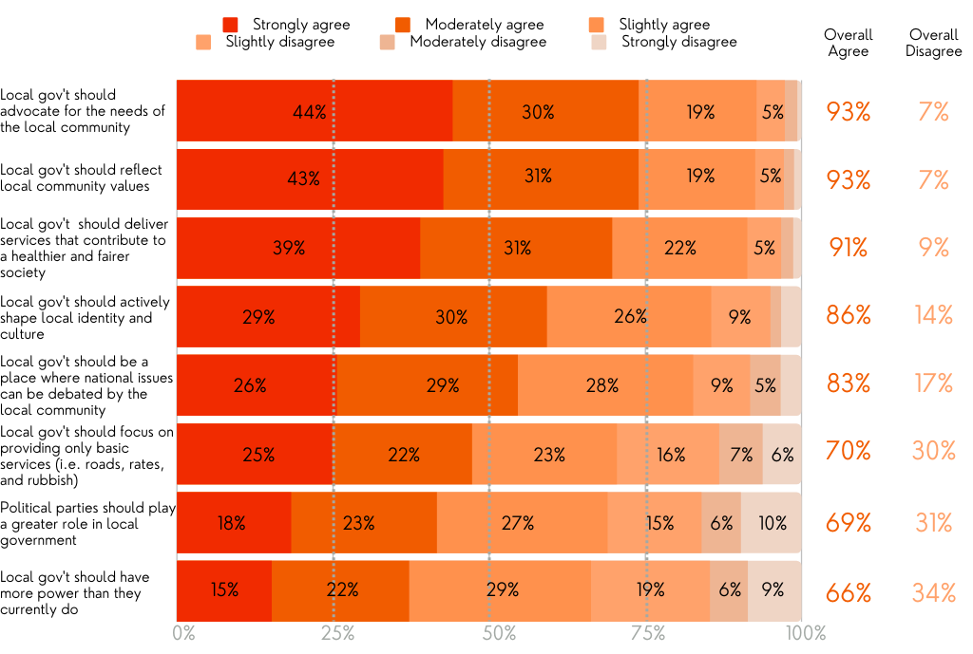
Survey question: Q11. Thinking about the role of local government in Australia, do you agree or disagree with the following statements…?

When broken down by age, the three broad age groups (18-34; 35-54; 55+) only appeared the same in their levels of agreement with regard to whether local government should actively shape local identity and culture. Significantly, the results suggest that respondents over 55 were most supportive of an expansive role for local government, though they were less supportive than the other two age groups that political parties should play a greater role in local government and that local government should be a place where national issues can be debated. When analysed by gender, we saw greater alignment, but there were nevertheless several statistically significant differences. Indeed, women were seen to more strongly agree than men that there should be a greater role for local government beyond the Three Rs. For instance, where 64 percent of women agreed that local government should focus on providing only basic services, 79 percent of men believed the same. Conversely, compared to the 63 percent of men who believed that political parties should play a greater role in local government, 75 percent of women thought this should be the case. Finally, in relation to council type, we found no statistically significant differences in responses. The only exception was in relation to the question of whether local governments should have greater power than they currently do. On this issue, those living in metropolitan local government areas (69 percent) tended to agree that local governments should be given more powers compared to those living in rural local government areas (51 percent).

Local government and service provision
On the matter of specific service provision, our survey showed that while basic services (i.e. street cleaning and waste management, roads and bridges, and footpaths and cycleways) were regarded as the most important services, majorities of respondents still felt that a variety of social services were ‘extremely important’ or ‘very important’ for local governments to engage in as well (Figure 2). It is noteworthy that the most contentious and unconventional services listed (i.e. refugee support, LGBTQIA+ support and advocacy, and provision of supervised injecting rooms) had the least overall support.

Figure 2. Views on the importance of services for local government to provide
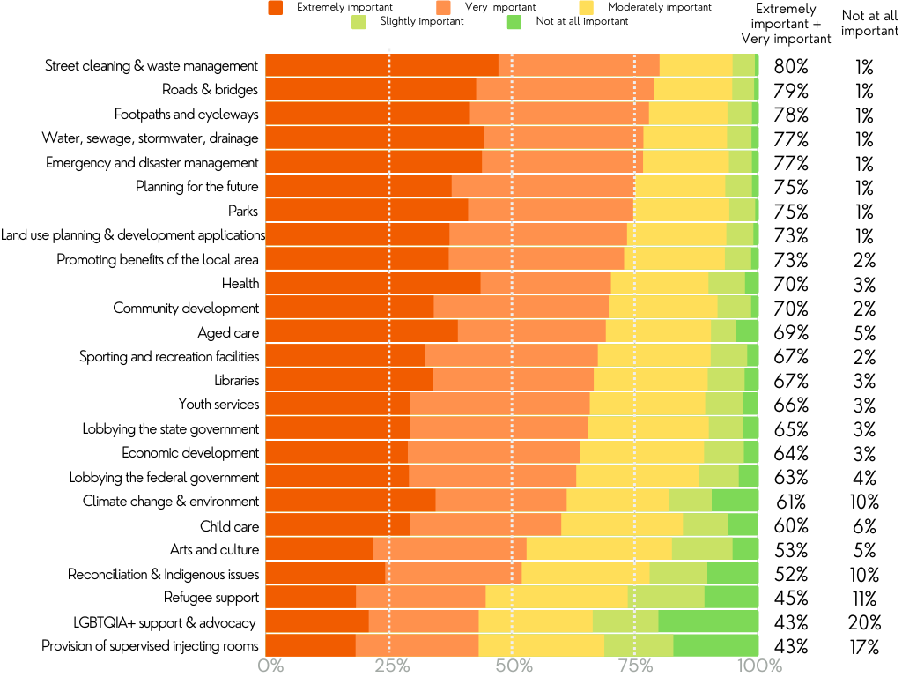
Survey question: Q12. The following is a list of different services and activities that Australian local governments can engage in. How important it is to you that local government engage in each of these things?

Regarding age, we found statistically significant differences across the three age groups for all of the services, barring health and youth services (Table 3). Nevertheless, there was rough agreement in terms of the relative importance of these services. In relation to the services regarded as ‘extremely important’ or ‘very important’, there was a relatively strong positive correlation between the responses of younger and middle-aged people (r=0.748; p=1.752e-05), a moderate positive correlation between those of younger and older people (r= 0.632; p=0.001), and a strong positive correlation between those of middle-aged and older people (r=0.947; p=0.000). Interestingly, younger respondents were more supportive than older respondents for local government to tackle more contentious and unconventional services.

Table 3. Views on the importance of services for local government to provide by age group
The following is a list of different services and activities that Australian local governments can engage in. How important it is to you that local government engage in each of these things? | strongly agree + moderately agree + slightly agree |  |  | χ² statistic* | p-value
 | 18-34 | 35-54 | 55+
Water, sewage, stormwater, drainage | 69% | 77% | 65% | 68.3 | 1.057e-11
Roads and bridges | 68% | 79% | 89% | NA** | 4.998e-4
Parks | 64% | 75% | 84% | NA** | 4.998e-4
Footpaths and cycleways | 69% | 77% | 87% | 59.1 | 6.93e-10
Land use planning and development applications | 66% | 72% | 82% | NA** | 4.998e-4
Street cleaning and waste management | 66% | 81% | 91% | NA** | 4.998e-4
Health | 70% | 71% | 69% | 4.9 | 0.772
Provision of supervised injecting rooms | 51% | 46% | 33% | 109.4 | < 2.2e-16
Child care | 67% | 61% | 52% | 30.8 | 1.528e-4
Climate change and environment | 64% | 64% | 55% | 77.7 | 1.39e-13
Aged care | 65% | 71% | 70% | 27.2 | 6.402e-4
Emergency and disaster management | 70% | 76% | 83% | 28.7 | 3.612e-4
Libraries | 57% | 67% | 75% | 46.2 | 2.198e-07
Sporting and recreation facilities | 56% | 68% | 78% | 56.1 | 2.741e-09
Reconciliation and Indigenous issues | 61% | 54% | 41% | 73.9 | 8.204e-13
Arts and culture | 56% | 57% | 46% | 27.2 | 6.56e-4
Economic development | 61% | 66% | 64% | 17.8 | 2.302e-2
LGBTQIA+ support and advocacy | 58% | 40% | 32% | 100.6 | < 2.2e-16
Youth services | 65% | 67% | 65% | 5.9 | 0.658
Community development | 64% | 70% | 75% | 19.0 | 1.497e-2
Refugee support | 56% | 43% | 36% | 59.3 | 6.304e-10
Planning for the future | 70% | 73% | 82% | 27.8 | 5.177e-4
Promoting the benefits of the local area | 65% | 70% | 82% | 49.7 | 4.592e-08
Lobbying the state government | 57% | 64% | 75% | 52.3 | 1.464e-08
Lobbying the federal government | 58% | 61% | 70% | 37.3 | 1.002e-05
* Chi-square test of 3x6 tables (3IVs and 6DVs)
** Fisher's test was used here because the data did not fit the assumptions of the Chi-squared test
Note: Statistically significant variables (α=0.05) have been bolded; shading has been provided as a visual aid to show more (darker) and less (lighter) agreement

Similarly, a strong positive relationship existed between women’s and men’s rankings of how important certain services are for local governments to provide (r=0.927; p=2.924e-11). Despite this, women felt more strongly than men about the importance of local government providing a number of socially and environmentally oriented services, including health, child care, climate change and environment, arts and culture, and youth services (Table 4).

Table 4. Views on the importance of services for local government to provide by gender
Q12. The following is a list of different services and activities that Australian local governments can engage in. How important it is to you that local government engage in each of these things? | extremely important + very important |  | Chi-square statistic* | p-value
 | Female | Male
Water, sewage, stormwater, drainage | 75% | 79% | 3.5 | 0.474
Roads and bridges | 78% | 80% | 2.7 | 0.616
Parks | 72% | 77% | N/A** | 0.063
Footpaths and cycleways | 78% | 78% | 3.0 | 0.558
Land use planning and development applications | 72% | 74% | 3.0 | 0.560
Street cleaning and waste management | 78% | 82% | 11.6 | 0.021
Health | 75% | 64% | 27.1 | 1.89e-05
Provision of supervised injecting rooms | 47% | 39% | 28.7 | 8.796e-06
Child care | 63% | 57% | 22.5 | 1.593e-4
Climate change and environment | 67% | 55% | 45.6 | 2.93e-09
Aged care | 73% | 64% | 27.8 | 1.346e-05
Emergency and disaster management | 78% | 75% | 13.3 | 9.9e-3
Libraries | 67% | 66% | 6.4 | 0.171
Sporting and recreation facilities | 66% | 69% | 3.6 | 0.457
Reconciliation and Indigenous issues | 58% | 45% | 42.2 | 1.532e-08
Arts and culture | 58% | 48% | 26.8 | 2.172e-05
Economic development | 68% | 60% | 11.5 | 0.021
LGBTQIA+ support and advocacy | 50% | 35% | 55.0 | 3.215e-11
Youth services | 69% | 62% | 10.8 | 0.029
Community development | 72% | 67% | 13.1 | 0.011
Refugee support | 48% | 40% | 26.8 | 2.146e-05
Planning for the future | 76% | 74% | 1.5 | 0.822
Promoting the benefits of the local area | 74% | 71% | 2.7 | 0.603
Lobbying the state government | 64% | 67% | 10.2 | 0.037
Lobbying the federal government | 63% | 64% | 4.0 | 0.412
* Chi-square test of 2x6 tables (2IVs and 6DVs)
** Fisher's test was used here because the data did not fit the assumptions of the Chi-squared test
Note: Statistically significant variables (α=0.05) have been bolded; shading has been provided as a visual aid to show more (darker) and less (lighter) agreement

Regarding local council type, a surprising finding was the broad consensus in relation to all but three services: aged care; planning for the future; and provision of supervised injecting rooms (Figure 3).

Figure 3. Views on the importance of aged care services, planning for the future, and provision of supervised injecting rooms, by local council type
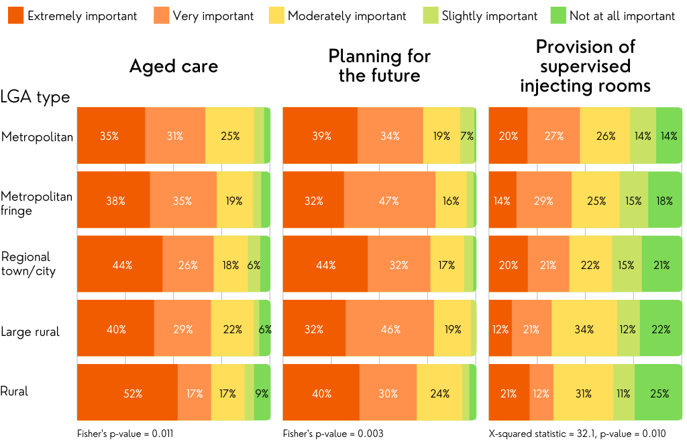

Local government and contentious political issues
Finally, clear majorities of survey respondents agreed to some extent that local government had a role engaging with contentious issues surrounding climate change, Indigenous reconciliation, and LGBTQIA+ issues (Figure 4). There was only one issue over which respondents were split between agreement and disagreement: changing the date of Australia Day from January 26.

Figure 4. Views on whether local government should engage in contentious issues
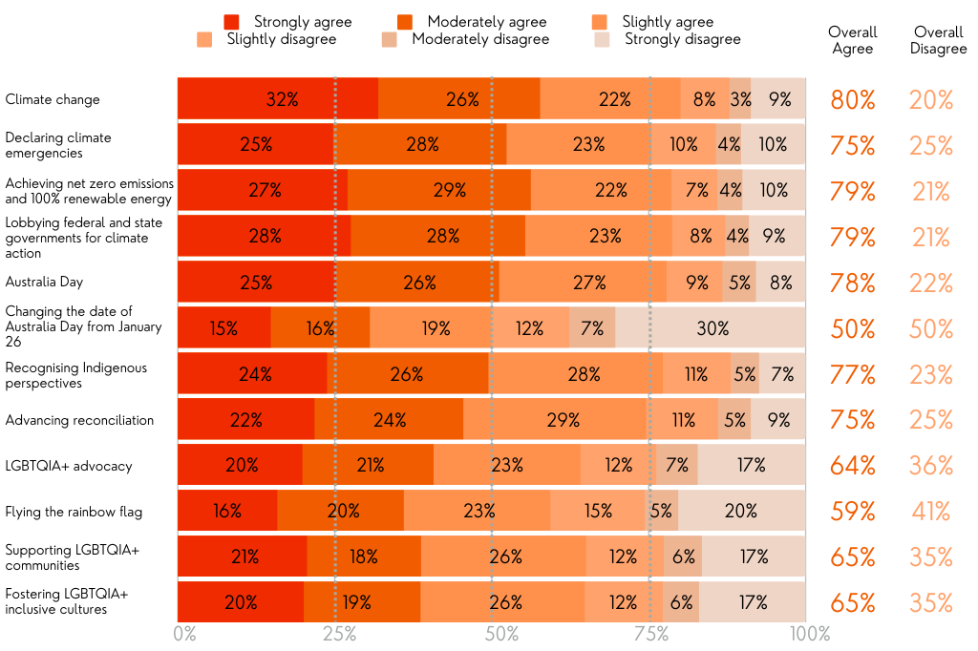
Survey question: Q14 - In recent years, Australian local governments have often made news for the roles they played in some of the country’s most contentious political issues. To what extent do you think local government should be engaging in these issues, in particular in relation to:

For both age group and gender, clear patterns emerged in relation to the extent to which these issues are regarded as important for local governments to engage in. With the exception of Australia Day, younger people (relative to middle aged people and older people) and women (relative to men) demonstrate stronger agreement that these issues should be within the purview of local government.
Finally, regarding local council type, there were no statistically significant differences, apart from changing the date of Australia Day. Figure 5 shows that, overall, slight majorities of metropolitan respondents agreed that local government should engage with the change the date issue, while majorities of regional and rural respondents indicated that local government should not engage. The disagreement was particularly stark in the case of rural respondents, with 67 percent disagreeing overall.

Figure 5. Views on whether Australian local governments should engage with the issue of changing the date of Australia Day from January 26, by local council type
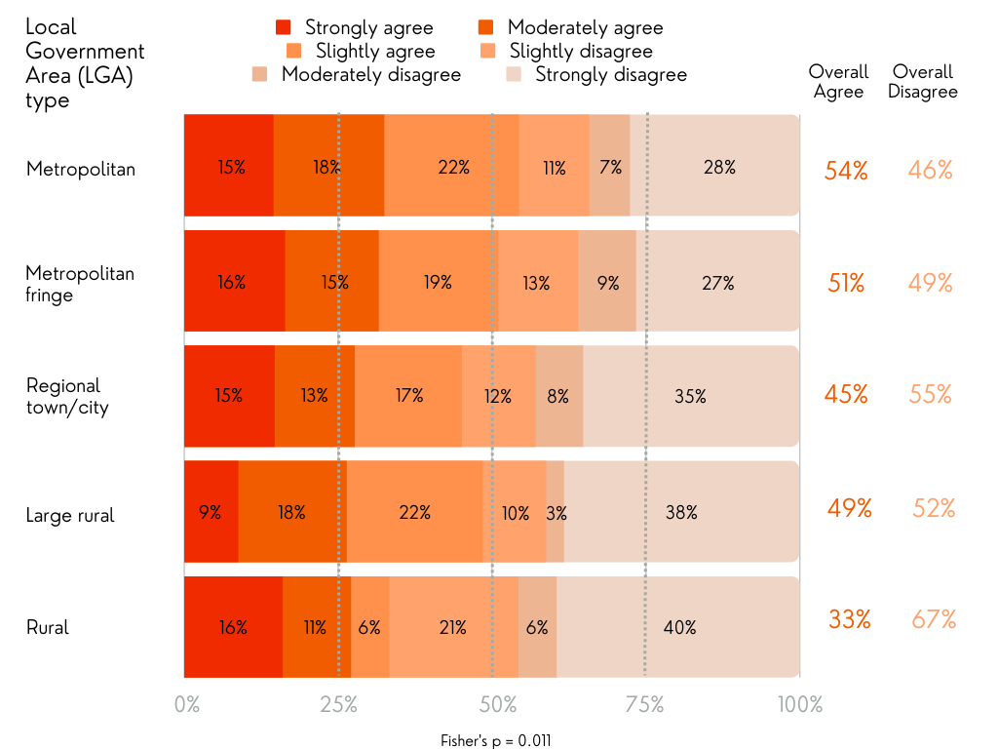

Discussion and Conclusion
Read together, three key observations can be drawn from these survey findings. The first is that Australians have now largely outgrown the three longstanding ideological underpinnings of Australian urban politics (Halligan and Paris, 1984): the ratepayer ideology that drives local government’s focus on the three Rs; the localist ideology that places the suburb and neighbourhood as the sole focus of local politics; and the ideology of political neutrality or the ‘opposition to politics in local government’. Indeed, despite the broad levels of support (70 percent) for the view that local government should focus on providing only basic services and the high importance placed on the services of street cleaning and waste management; roads and bridges; footpaths and cycleways; and water, sewerage, stormwater, and drainage, Australians now have a more complex and expansive view of local government. In short, local government should not to restricted to providing only basic services to property or, put differently, social services are as significant to the remit of local government as basic services. This is a point that comes across clearly in the high levels of overall support for local government to advocate for the community’s needs (93 percent), reflect community values (93 percent), deliver services that contribute to a healthier and fairer society (91 percent), and actively shape local identity and culture (86 percent).
These findings correlate broadly with the 2015 Australian Centre of Excellence for Local Government survey ‘Why Local Government Matters’ (Ryan et al., 2015). Indeed, despite the finding that 75 percent of respondents overall disagreed that local governments should focus on providing only basic services – essentially the inverse of our survey finding on the same question – it did find that more than nine in ten Australians agreed that local governments should deliver services that contribute to a healthier and fairer society and that they should be advocating for the needs of the local community. Read together, their findings also challenge more traditional conceptions about the function of local government being ‘strictly to service property’ (Halligan and Paris, 1984: 61). This was confirmed in our survey, which demonstrated overall majority support for socially-oriented services and initiatives to do with future planning, community development, lobbying higher governments, and climate change in particular rating high. While these findings do need to be interpreted against a broader historical backdrop – which has seen the roles and expectations of local government ebb and flow from jurisdiction to jurisdiction at different periods in time – our survey does show that a majority of Australians are now demanding more of their local councils.
Finally, strong support for the view that local government can be a place where national issues are debated locally (83 percent) and emerging majority support for an increased role of political parties in local government (69 percent) dispel the two other entrenched local government ideologies: localism and political neutrality. These findings highlight that a majority of Australians would now back the moves made by more and more local councils to tackle nationally significant matters like Australia Day, climate change, and more recently the Indigenous Voice to Parliament, sometimes in quite political and politicised ways (Dexter and Massola, 2022; https://greens.org.au/vic/councilachievements). One interesting caveat to round out this discussion, though, is that despite more Australians expecting a more diverse set of services from local councils, relatively few (66 percent) believed they should be given more powers to carry out these roles. The tension here speaks to a range of persistent challenges that Australian local councils face, from fiscal sustainability, rates and rate capping, to cost-shifting. These are challenges that more state governments, and even the federal government, will need to address in future should public demand for local council services continue to increase. Failure to do so may result in increased community dissatisfaction and distrust in local government.

This, then, leads to the second key observation: Australians increasingly have an appetite for local government to address contentious cultural and political issues. Although our survey revealed that Australians rated the provision of supervised injecting rooms, LGBTQIA+ support and advocacy, refugee support, and reconciliation and Indigenous issues as the least important services and activities for local government to engage in, clear majorities answered positively when asked to what extent local government should be engaging in contentious issues to do with climate change, Australia Day, and LGBTQIA+ support and advocacy. The only exception was on the specific question of local government changing the date of Australia Day, which was evenly split – perhaps a prelude to the unsuccessful 2023 Voice referendum. Despite this, the take away here is that a growing number of Australians accept that even contentious actions, such as climate emergency declarations and flying the rainbow flag, should be within local government’s remit.
At the broadest level, then, these findings only confirm local government’s growing mandate to be ‘place-shapers’ responsible for building local identity, maintaining community cohesion and representation, and growing the local economy (Grant and Dollery, 2011; Dollery et al., 2008; Lyons, 2007). But even more than that, it shows that there is now a clearer role for local government to govern ideologically contentious – or culture wars – issues. The growing chorus of local councils that have been jumping headfirst into national controversy by tackling issues like same-sex marriage (Greenwich and Robinson, 2018), Australia Day (Busbridge and Chou, 2022), the climate emergency (Greenfield et al., 2022), whether to fly the Australian flag on council buildings (McGregor, 2022), and pill testing (Topsfield, 2019) stand as the most polarising examples of local government initiatives in this realm. This is a matter that Australian urban politics scholarship has only just begun to reckon with (Busbridge and Chou, 2022; Chou and Busbridge, 2020; Chou and Busbridge, 2019). More systematic interdisciplinary research in urban studies, political science, and public administration is needed to fully comprehend how local councils should do this and what this might mean for intergovernmental relations within our federal hierarchy.
Finally, the third observation speaks to the relationship between local council type and understandings of the role of local government. While recent research in public administration has shown that local government category can be a determining factor when it comes to municipal expenditure, noting that ‘the determinants of municipal expenditure differ among the different categories of local government’ (Tran and Dollery, 2019: 646), our findings are revealing because they demonstrate how little effect local council category had in determining how residents conceived of the role of local government. Indeed, except for the notable differences of opinion among respondents living in metropolitan vis-à-vis rural local councils over the questions of giving local government more power and changing the date of Australia Day, few statistically significant differences were recorded across our survey. While the need for more ‘empirical research into behavioural differences among different kinds of local council’ is clear (Tran and Dollery, 2019: 646), the conclusion to draw from this research at least is equally clear: contrary to earlier research that shows that Australians living in regional and rural areas often have very different perceptions of local government’s role than Australians living in metropolitan areas (Hastings et al, 2016), more Australians – whether living in metropolitan or regional and rural areas – are increasingly seeing the role of local government in expansive terms. For representatives, administrators, and planners working in the local government sector, then, these findings should help affirm more diverse policy and planning agendas, as well as a clearer role for Australian local government beyond the Three Rs.

References
Aitkin, D. and Jinks, B. (1982). Australian Political Institutions. Melbourne: Pitman Books.
Aulich, C. (1999). From Convergence to Divergence: Reforming Australian Local Government. Australian Journal of Public Administration 58(2): 12-23.
Bell, P. (2006). How Local Governments Can Save Australia’s Federal System. In AJ. Brown and JA. Bellamy (eds.), Federalism and Regionalism in Australia: New Approaches, New Institutions? (Canberra: ANU E-Press, 2006): 171-184.
Brown, A.J. (2008). In Pursuit of the Genuine Partnership: Local Government and Federal Constitutional Reform in Australia. UNSW Law Journal 31(2): 435–466
Brown, A.J. (2006). Federalism, Regionalism and the Reshaping of Australian Governance. In In AJ. Brown and JA. Bellamy (eds.), Federalism and Regionalism in Australia: New Approaches, New Institutions? (Canberra: ANU E-Press, 2006): 11-32.
Busbridge, R. (2023). Changing the Date: Local Councils, Australia Day and Cultures of National Commemoration. Journal of Sociology 59(2): 430–420.
Busbridge, R and Chou, M. (2022). Culture War and City Politics, Revisited: Local Councils and the Australia Day Controversy. Urban Affairs Review 58(1): 68-102.
Chou, M. and Busbridge, R. (2020). How Local Governments Govern Culture War Conflicts. Cambridge: Cambridge University Press.
Chou, M. and Busbridge, R. (2019). Culture Wars, Local Government, and the Australia Day Controversy: Insights from Urban Politics Research. Urban Policy and Research 37(3): 367-377.
Colebatch, H.K. and Degeling, P.J. (1986). Understanding Local Government: Action, Linkage, Outcome. Canberra: Canberra College of Advanced Education.
Commonwealth Grants Commission (2001). Review of the Operation of the Local Government (Financial Assistance) Act 1995, June.
Dexter, R. and Massola, J. (2022). End of Australia Day Citizenship Edit Spurs More Councils to Reconsider the Date. The Age 16 December. https://www.theage.com.au/politics/victoria/end-of-australia-day-citizenship-edict-spurs-more-councils-to-reconsider-the-date-20221216-p5c6yz.html.
Dollery, B., Crase, L, and Johnson, A. (2006). Australian Local Government Economics. Sydney: UNSW Press.
Dollery, B., Goode, S., and Grant, B. (2010). Structural Reform of Local Government in Australia: A Sustainable Amalgamation Model for Country Councils. Space and Polity 14(3): 289-304.
Dollery, B., Grant, B., and O’Keefe, S. (2008). Local Councils as ‘Place-Shapers’: The Implications of the Lyons Report for Australian Local Government. Australian Journal of Political Science 43(3): 481-494.
Dollery, B., O’Keefe, S., and Crase, L. (2009). State Oversight Models for Australian Local Government. Economic Papers 28(4): 279-290.Dollery, B., Wallis, J., and Percy, A. (2006). The Debate that Had to Happen But Never Did: The Changing Role of Australian Local Government. Australian Journal of Political Science 41(4): 553-567.
Grant, B. and Dollery, B. (2011). Political Geography as Public Policy? ‘Place-Shaping’ as a Model of Local Government Reform. Ethics, Politics, and Environment 14(2): 193-209.
Grant, B. and Drew, J. (2017). Local Government in Australia: History, Theory and Public Policy. Singapore: Springer.
Greenfield, A., Moloney, S., and Granberg, M. (2022). Climate Emergencies in Australian Local Governments: From Symbolic Act to Disrupting the Status Quo? Climate 10: 38.
Greens Local Councillor Achievements. https://greens.org.au/vic/councilachievements.
Greenwich, A. and Robinson, S. (2018). Yes, Yes, Yes: Australia’s Journey to Marriage Equality (Sydney: NewSouth Publishing).
Halligan, J. and Paris, C. (1984). The Politics of Local Government. In J. Halligan and C. Paris (eds.), Australian Urban Politics: Critical Perspectives (Melbourne: Longman Cheshire, 1984): 58-72.
Hastings, C., Wortley, L., Ryan, R., and Grant, B. (2016). Community Expectations for the Role of Local Government in Regional Australia: Meeting the Challenges of ‘Slow Burn’. Australasian Journal of Regional Studies 22(1): 158–180.
Hawker, D. (2003). Rates and Taxes: A Fair Share for Responsible Local Government. Parliament of Australia, 24 November. https://www.aph.gov.au/Parliamentary_Business/Committees/House_of_Representatives_Committees?url=efpa/localgovt/report.htm.
Lyons, M. (2007). Place-shaping: A Shared Ambition for the Future of Local Government, Final Report. London: The Stationery Office.
McGregor, T. (2022). Australian Council Slammed for ‘Unbelievable’ Ban. News.com.au 8 October. https://www.news.com.au/national/australian-council-slammed-for-unbelievable-ban/news-story/10c195b1ba95fdb2dab86bad6375d63f.
Megarrity, L. (2011). Local Government and the Commonwealth: An Evolving Relationship. Research Paper No.10 2010-11. Parliament of Australia. 31 January. https://www.aph.gov.au/About_Parliament/Parliamentary_Departments/Parliamentary_Library/pubs/rp/rp1011/11RP10.
Palus, C.K. (2010). Responsiveness in American Local Governments. State and Local Government 42(2): 133–150.
Productivity Commission. (2012). Performance Benchmarking of Australian Business Regulation: The Role of Local Government as Regulator. 18 July. Canberra: Commonwealth of Australia.
Rosenthal, C.S. (2005). Local Politics: A Different Front in the Culture War? The Forum 3(2).
Rozner, R. (2020). Poll: Local Councils Should Stick to Roads, Rates and Rubbish. Institute of Public Affairs 19 February. https://ipa.org.au/publications-ipa/poll-local-councils-should-stick-to-roads-rates-and-rubbish.
Ryan, R., Hastings, C., Woods., R., Lawrie, A., Grant, B. (2015) Why Local Government Matters: Summary Report 2015. Australian Centre of Excellence for Local Government. University of Technology Sydney Australia. https://www.uts.edu.au/sites/default/files/WhyLocalGovernmentMatters-FullReport.pdf.
Ryan, R. and Woods, R. (2015). Local Government Capacity in Australia. Public Policy and Administration 14(3): 225-248.
Sharp, E. (ed.). (1999). Culture Wars and Local Politics. Lawrence: University Press of Kansas.
Sharp, E., (1996). Culture Wars and City Politics: Local Government’s Role in Social Conflict. Urban Affairs Review 31(6): 738–758.
Tran, C.T.T. and Dollery, B. (2019). Council Type and the Determinants of Municipal Expenditure: A Semiparametric Analysis of South Australian Local Government. Australian Journal of Public Administration 78(4): 631-650.
Topsfield, J. (2019). Lord Mayor Backs a Pill-Testing Trial but Andrews Just Says ‘No’. The Age 12 November. https://www.theage.com.au/national/victoria/lord-mayor-backs-a-pill-testing-trial-but-andrews-just-says-no-20191112-p539y4.html.
Watt, P.A. (2006) Principles and Theories of Local Government. Economic Affairs (Journal of the Institute of Economic Affairs) March: 4-10.
Whitlam, E.G. (1977). 1972 Party Policy Speech. In E.G. Whitlam, On Australia’s Constitution (Camberwell: Widescope, 1977): 265-307.
Whitlam, E.G. (1977). The Commonwealth and Local Authorities: The Way Forward. In E.G. Whitlam, On Australia’s Constitution (Camberwell: Widescope, 1977): 111-123.

.

Appendix A

Thinking about the role of local government in Australia, do you agree or disagree with the following statements:
- Local government should focus on providing only basic services (i.e. roads, rates, and rubbish);
- Local government should deliver services that contribute to a healthier and fairer society;
- Local government should have more power than they currently do;
- Local government should advocate for the needs of the local community;
- Local government should reflect local community values;
- Local government should actively shape local identity and culture;
- Local government should be a place where national issues can be debated by the local community;
- Political parties should play a greater role in local government.

The survey distinguished five local council types to help identify whether there was a relationship between where respondents lived and their view on the role of local government: Metropolitan (part of an urban centre with a population greater than 1 million residents); Metropolitan fringe (a LGA on the margin of an urban centre); Regional town/city (part of an urban centre with a population less than 1 million residents); Large rural (population between 10,000 and 20,000 residents); and Rural (population under 10,000 residents).

