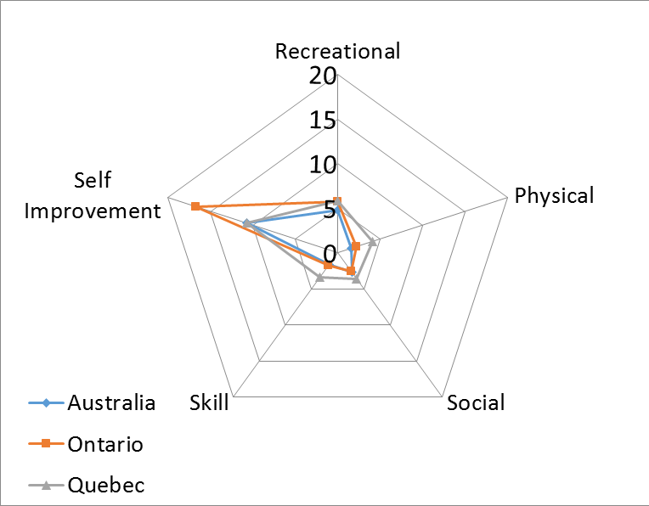

Supplementary Figure 2. Regional differences in proportion of Doing Non Preferred activities by Activity Type. The polar graph axes display each of the five Activity Types. Each bar of the graph equates to an increase in proportion of 5%. The three regions are plotted in different colours. The further from the center of the graph, the greater the percentage of children Doing Non Preferred activities in each region.

