This form must be completed by a research candidate; and checked by their supervisor for coherence and suitability for publishing.
The form must be submitted together with the thesis via ACU ResearchBank and should:
- indicate broadly what the research is about;
- state the major outcome of the research; and
- provide details of the contribution the research has made to our society and the knowledge of the area.
Notes:
- The Layperson’s Summary may be edited by the University and read at a graduation ceremony or be included in a media release by Marketing and External Relations.
- For privacy reasons, the final version of your thesis should not contain personal information such as your address or phone number, nor any sensitive references to family members in your acknowledgements. The thesis will be made available to the public via ACU Library Research Bank.
For assistance please contact Candidature Services (res.cand@acu.edu.au).

Part 1: Candidate Details
Student ID | S00067330
First Name | Daniella
Family Name | Taranto

Part 2: Program Details
Degree | Master of Education (Research)
Principal Supervisor | Emeritus Professor Tania Aspland
Co-supervisor | Professor Bruce Burnett

Part 3: Layperson’s Summary
Please provide your summary below (100 word limit):
Thesis title:
Teacher Perspectives on Self-Regulated Learning (SRL) Implementation and Reading Comprehension

Summary:
This thesis examines Grades 5 and 6 teachers' perspectives on implementing Self-Regulated Learning (SRL) for reading comprehension in a Catholic Primary School in Victoria, Australia. Teachers emphasised the importance of diverse SRL-focused professional development approaches to enhance their SRL knowledge, pedagogy, and performance. The study underscores the necessity of fostering student readiness for SRL through constructivist principles, encompassing conceptual understanding, epistemological beliefs, and personal relevance. Additionally, it identified the role of reading-specific epistemological beliefs and social interactions in students' SRL skill development. The resulting Lyceum Model provides a comprehensive framework for effective SRL implementation and reading comprehension in primary schools.

Part 4: Signature of Candidate
Signature | Date 21/12/2023

Part 5: Signature of Principal Supervisor
Signature 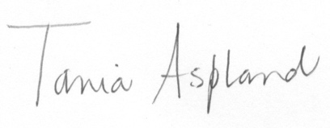 | Date 21/12/2023

